Assignment-17.3
Shaik Sabina
2303A51303
Batch-05

Task-01:
Prompt: Write a Python program using the pandas library to clean an employee dataset (employee_data.csv). The program should handle missing values by
filling the salary column with its median, replacing missing designation values with "unknown", and filling missing experience with the mean. It should remove duplicate records based on employee_id, standardize the designation column by converting text to lowercase and removing extra spaces, and then apply label encoding to the designation column. Additionally, perform one-hot encoding on the employment_type column. The program must display the dataset before and after cleaning and finally save the cleaned dataset as clean_employee_data.csv.
Ensure the code is well-structured and includes clear comments.
Code:

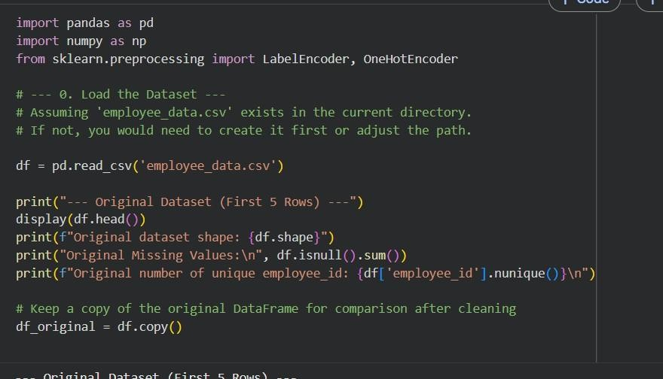
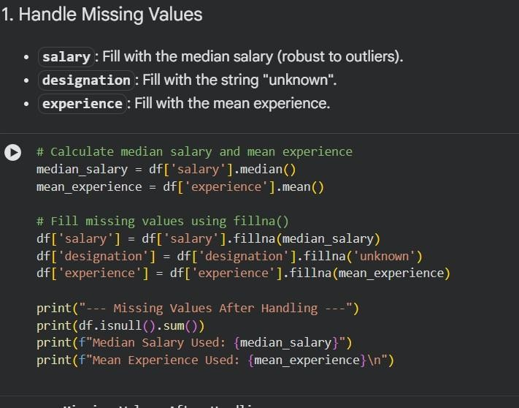

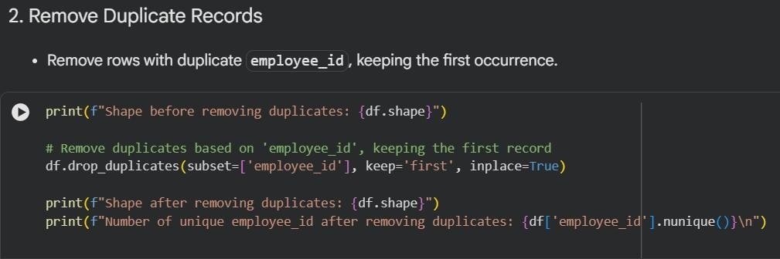
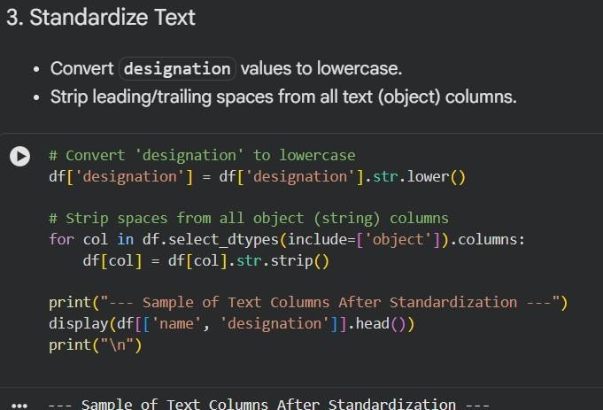

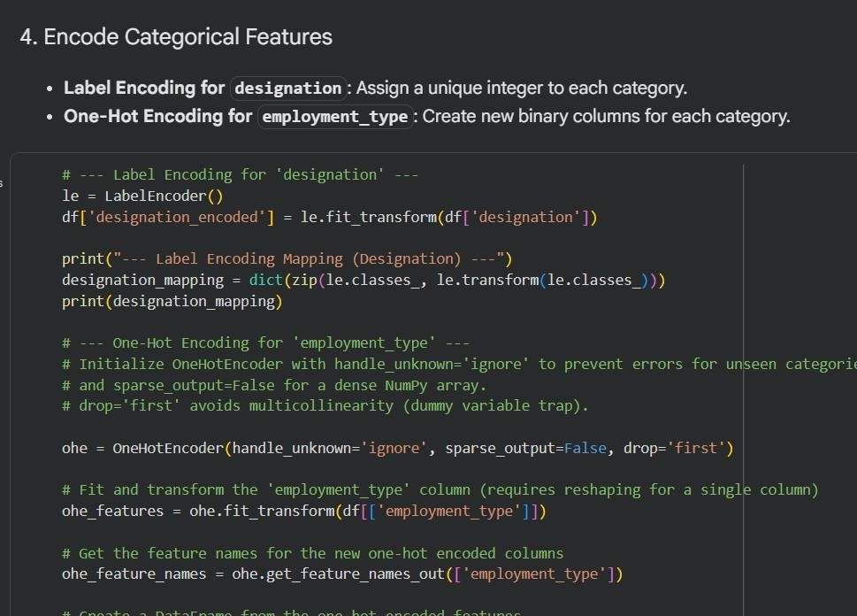
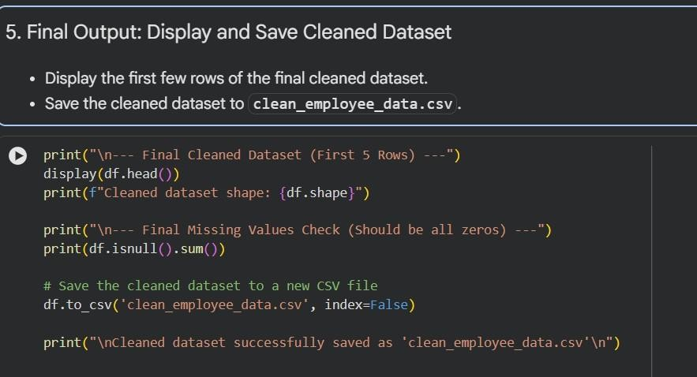

Output:
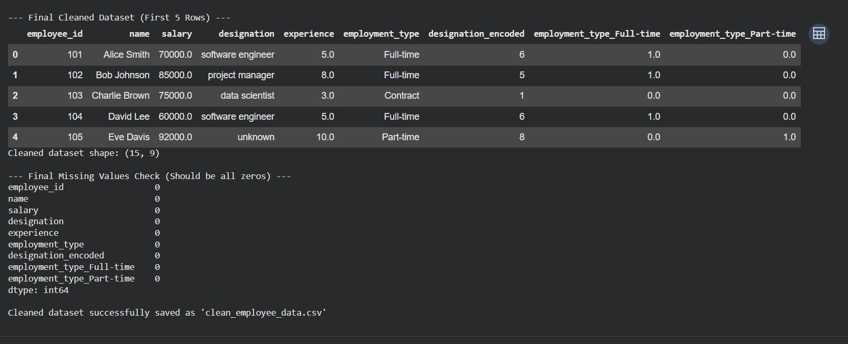
Explanation:
The program loads an employee dataset using pandas and displays it to show the original data before any preprocessing. It then handles missing values by filling the salary column with the median, replacing missing designation entries with "unknown", and updating missing experience values with the mean to ensure smooth analysis. Duplicate entries based on employee_id are removed so that each employee record remains unique.
Next, the program standardizes text data by removing extra spaces and
converting job titles to lowercase for uniformity. It then transforms categorical columns into numerical formats suitable for machine learning models. Finally, the cleaned dataset is saved as a new CSV file for further use.

Task-02:
Prompt: Use the dataset file student_data.csv to perform preprocessing by first importing the necessary libraries such as pandas, numpy, and sklearn. Convert the exam_date column into datetime format and derive additional columns like month, semester, and day from it. Apply Min-Max scaling to normalize the total_marks column, and identify as well as handle outliers using the IQR
method. Display the dataset both before and after preprocessing to observe the changes, and finally save the processed data as processed_student_data.csv with an option to download it. Ensure the code is neatly structured, well-commented, and ready to execute.
Code:

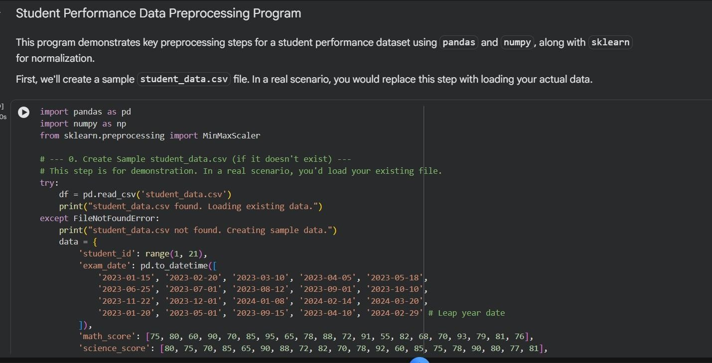
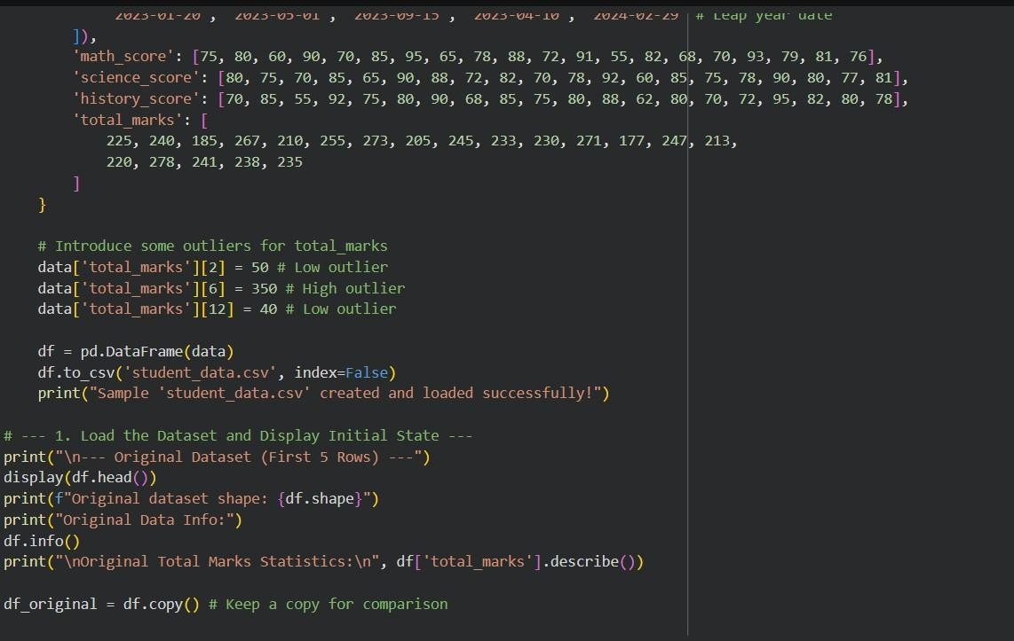

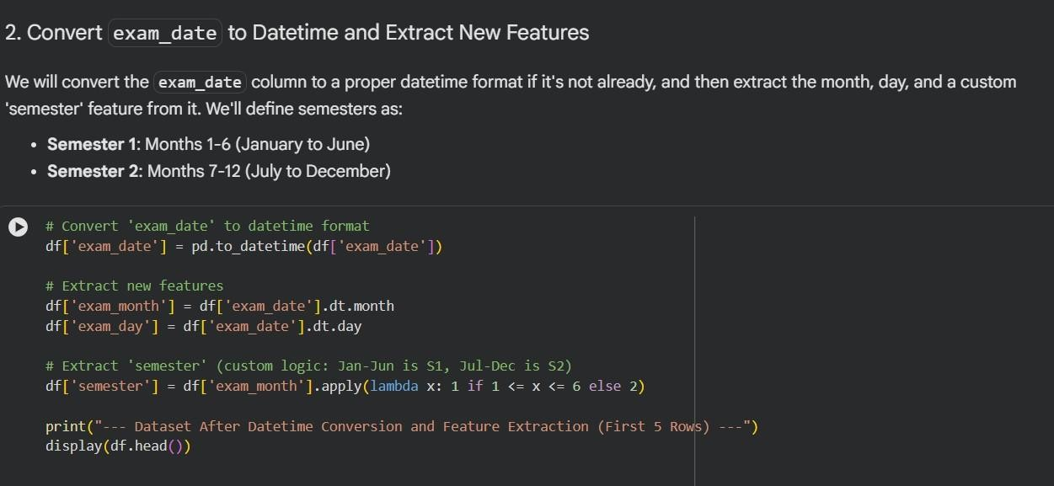
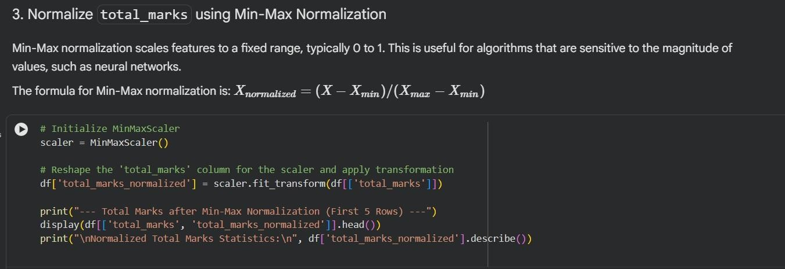
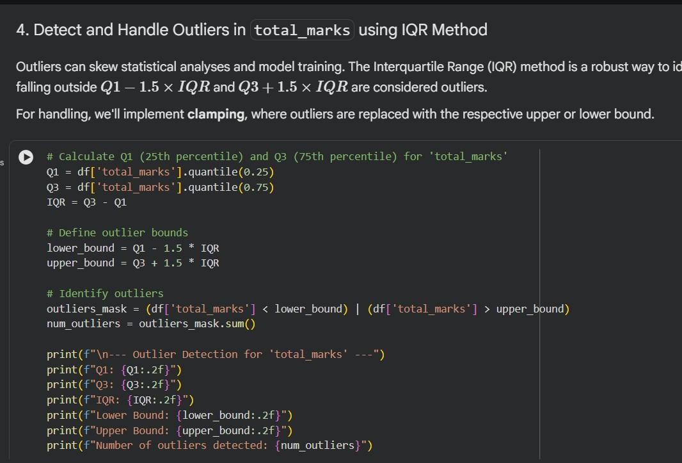

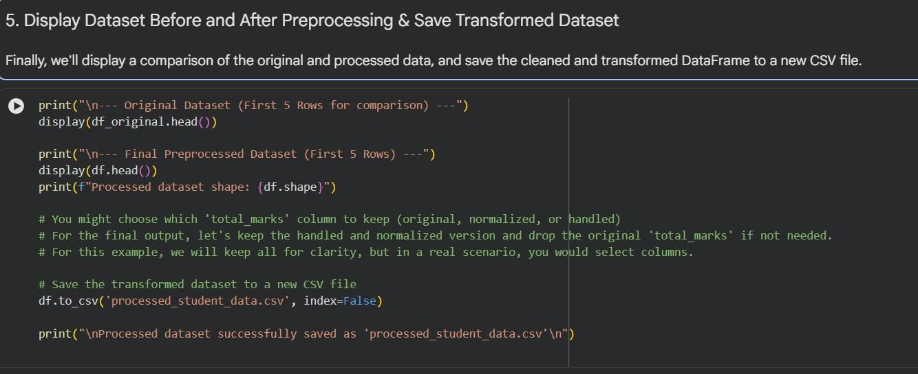
Output:
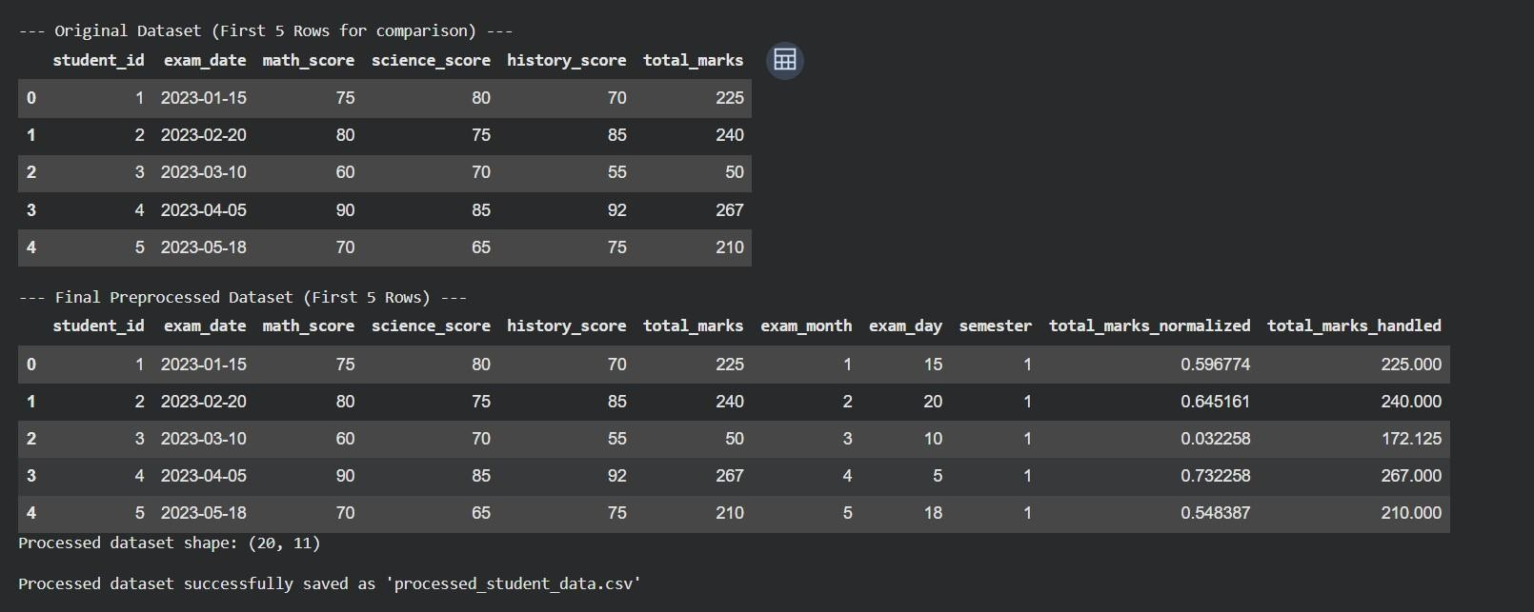
Explanation:
The program begins by importing essential libraries such as pandas, numpy, and sklearn, and then loads the student dataset into Google Colab. It transforms the exam_date column into datetime format to enable accurate date-related
operations. From this column, additional features like month, semester, and day are derived to enhance the dataset for analysis and predictive tasks.
Next, the total_marks column is scaled using Min-Max normalization to bring all values within a uniform range. The code also identifies outliers in the marks using the IQR method and handles them appropriately by either removing or adjusting extreme values. In the end, the processed dataset is stored as a new CSV file for future use.

Task-03:
Prompt:
Create a complete Python program to preprocess a student health dataset (student_health.csv) by first importing the required libraries such as pandas and components from sklearn, and then loading the dataset. Handle missing values by filling the height and weight columns with their mean values, and the BMI column with the median. Convert categorical features like medical_condition and fitness_status into numerical form using label encoding.
Next, standardize the numerical columns (height, weight, BMI) using
StandardScaler to bring them to a common scale. Split the dataset into training and testing sets with an 80:20 ratio. Display a few samples of the processed data to verify the changes, and finally save the cleaned and transformed dataset as processed_student_health.csv.
Code:
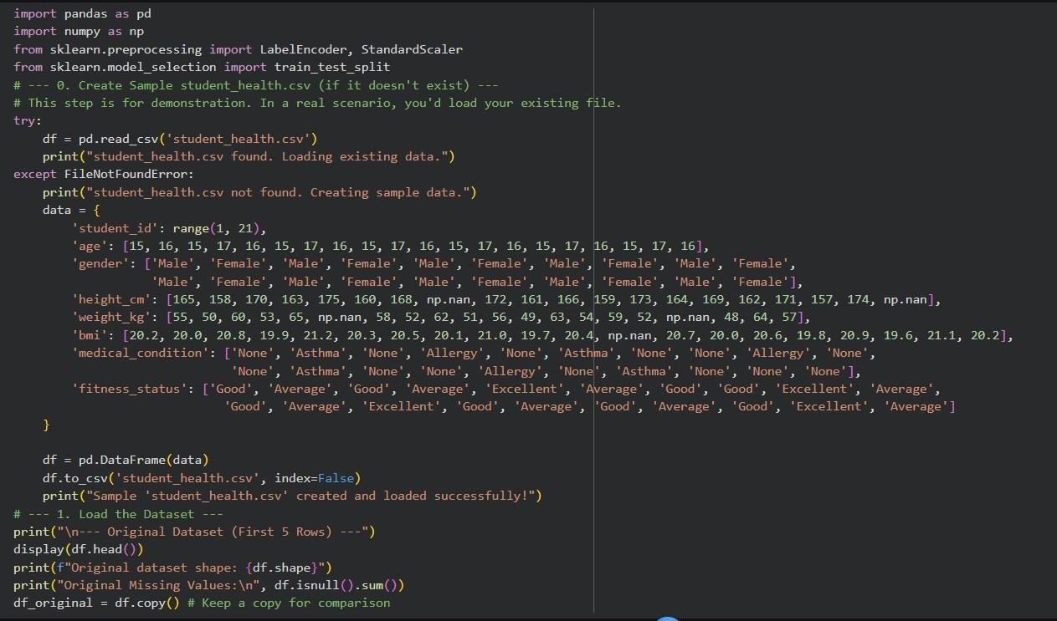

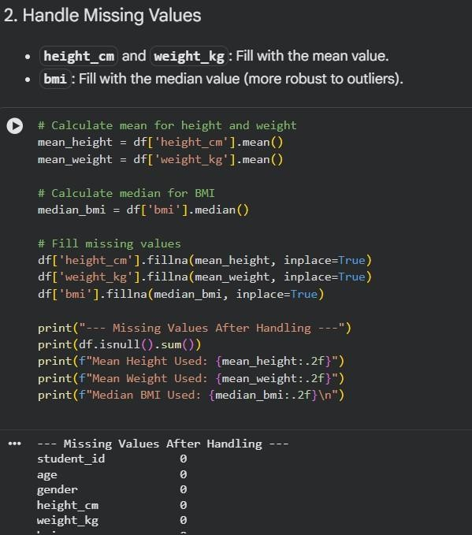

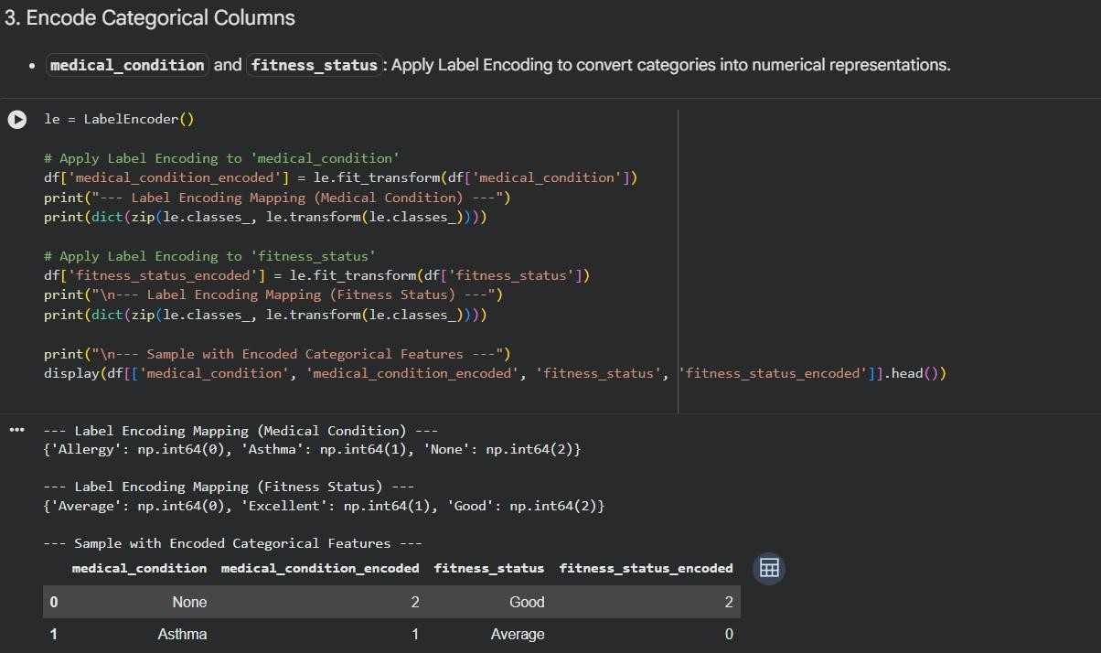
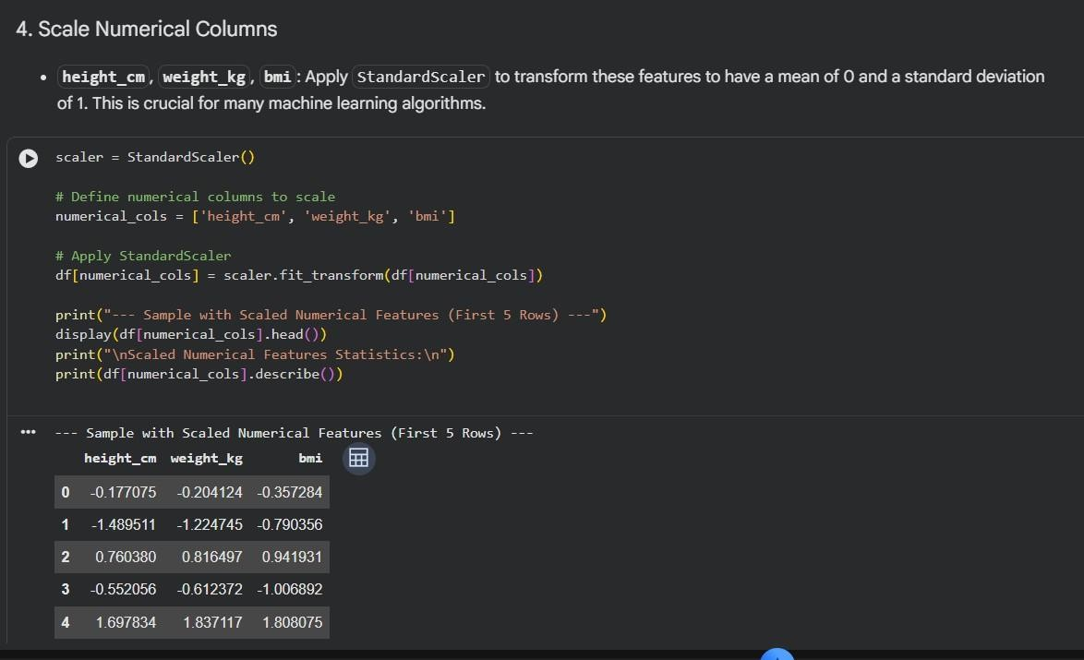

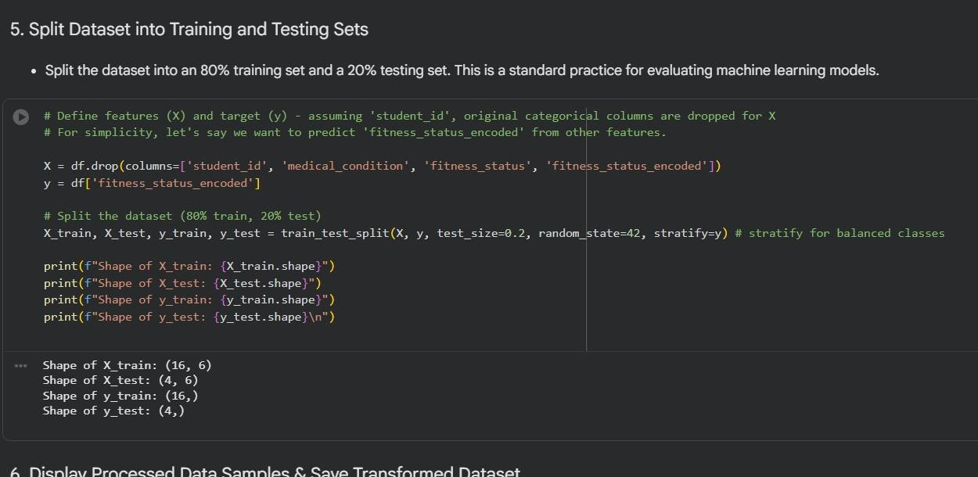
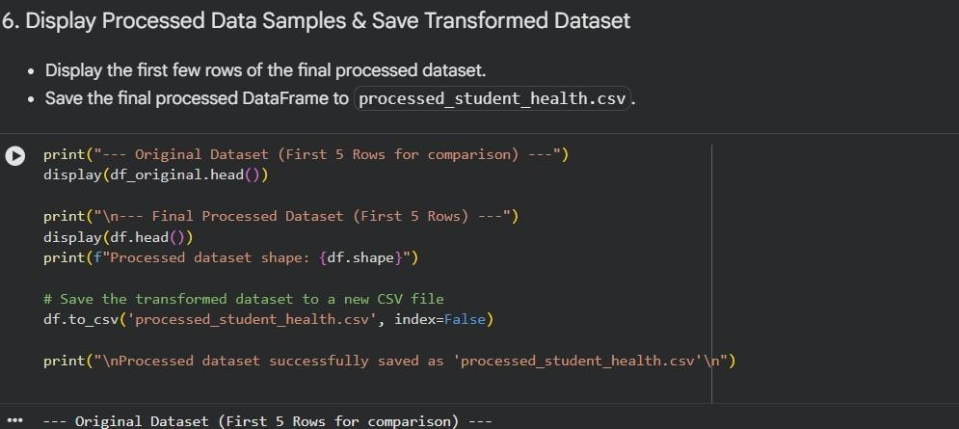

Output:
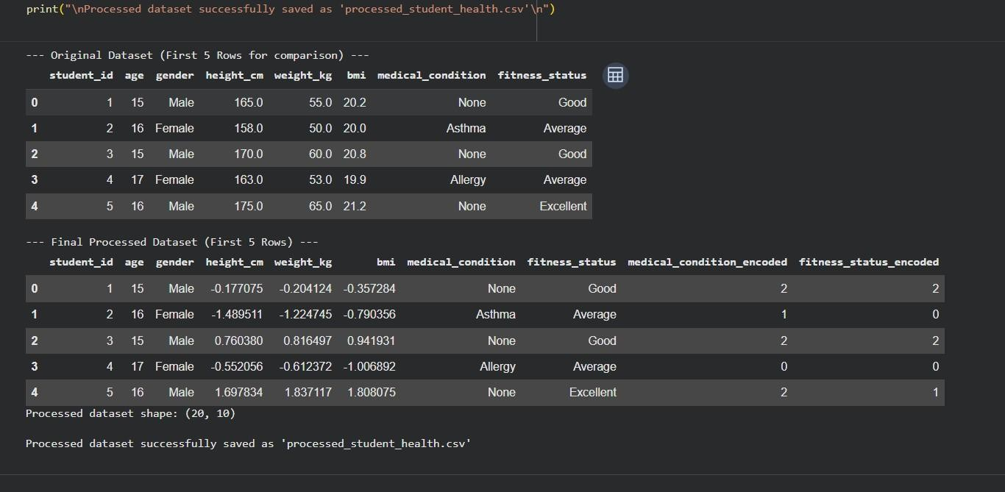

Explanation:
The code starts by importing pandas for managing data and sklearn utilities for preprocessing and splitting the dataset. It then loads the student health dataset and handles missing values by filling height and weight with their mean values, while BMI is replaced with the median to minimize the effect of extreme values.
Next, categorical fields such as medical condition and fitness status are
transformed into numerical form using label encoding, making them suitable for machine learning models. The numerical attributes are then standardized using StandardScaler, ensuring they have a mean of 0 and a standard deviation of 1 for
balanced model performance. Finally, the dataset is split into training and testing sets for analysis, and the processed data is saved as a new CSV file.

Task-04:
Prompt: Develop a Python program using pandas and sklearn to clean a ride- sharing dataset (rides_data.csv). Begin by loading the dataset, then standardize the pickup_location and drop_location columns by converting text to lowercase and removing extra spaces for consistency. Handle missing values in the
fare_amount column by filling them with the median fare.
Next, eliminate duplicate records based on ride_id to ensure each trip is unique. Normalize the driver_rating column using Min-Max scaling so values fall within a consistent range. Generate a summary that reports the number of missing
values handled, duplicates removed, and columns that were transformed. Display the dataset before and after cleaning, and finally save the processed dataset as
clean_rides_data.csv.

Code:

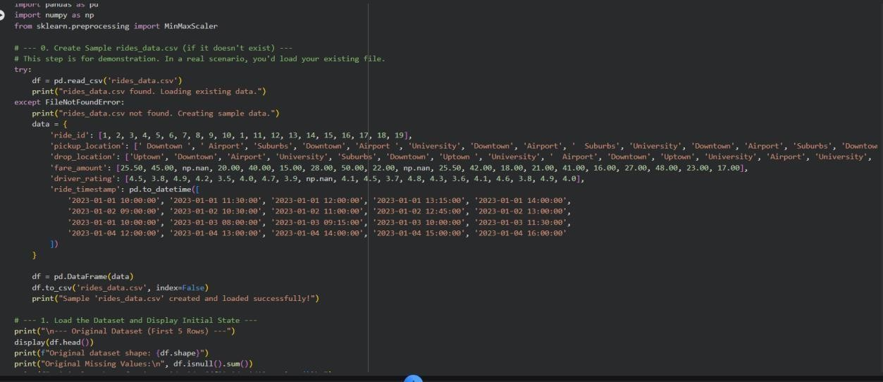
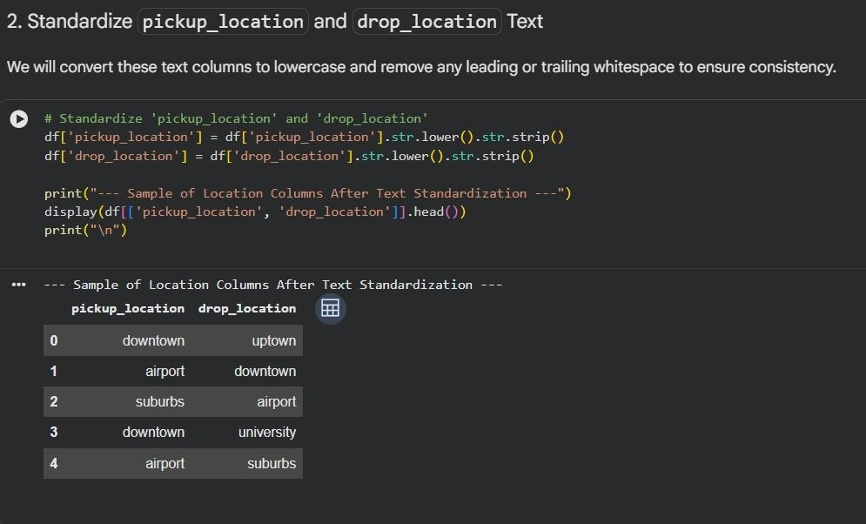

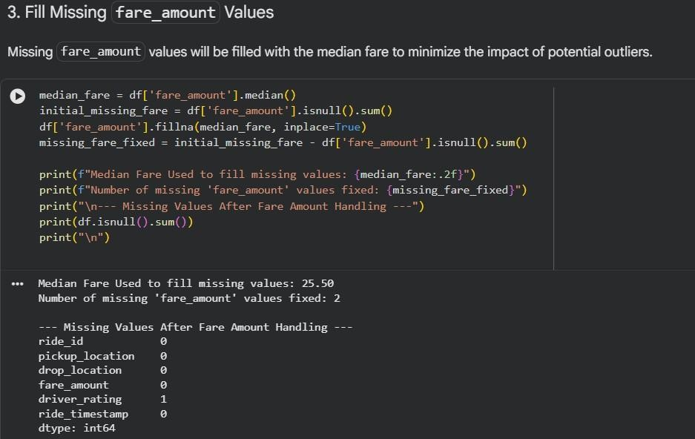
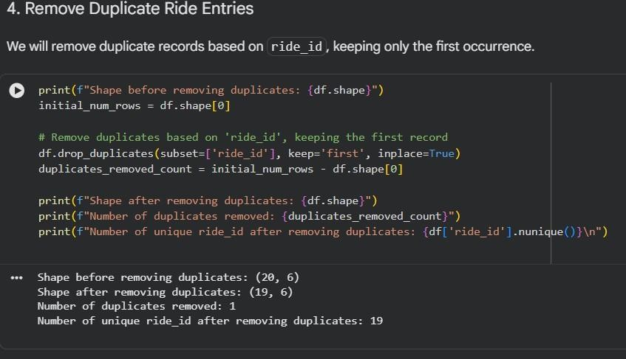

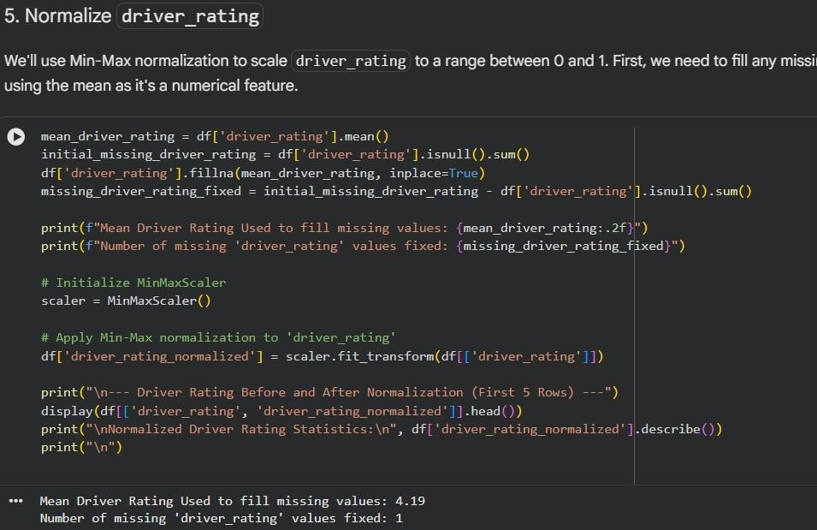

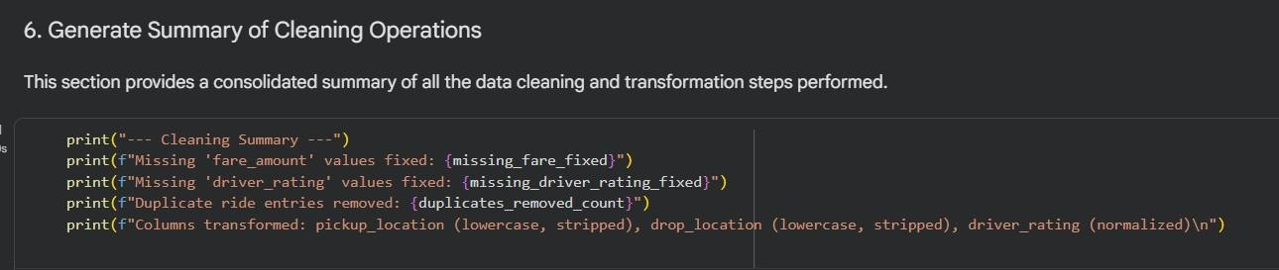

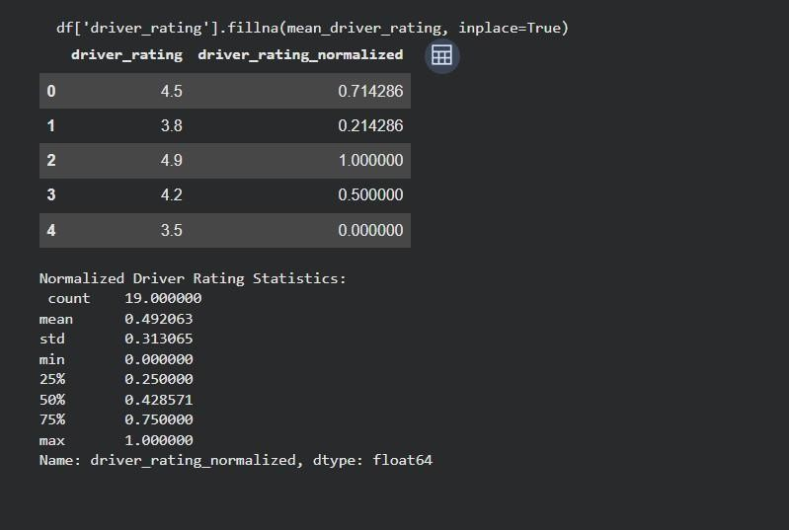
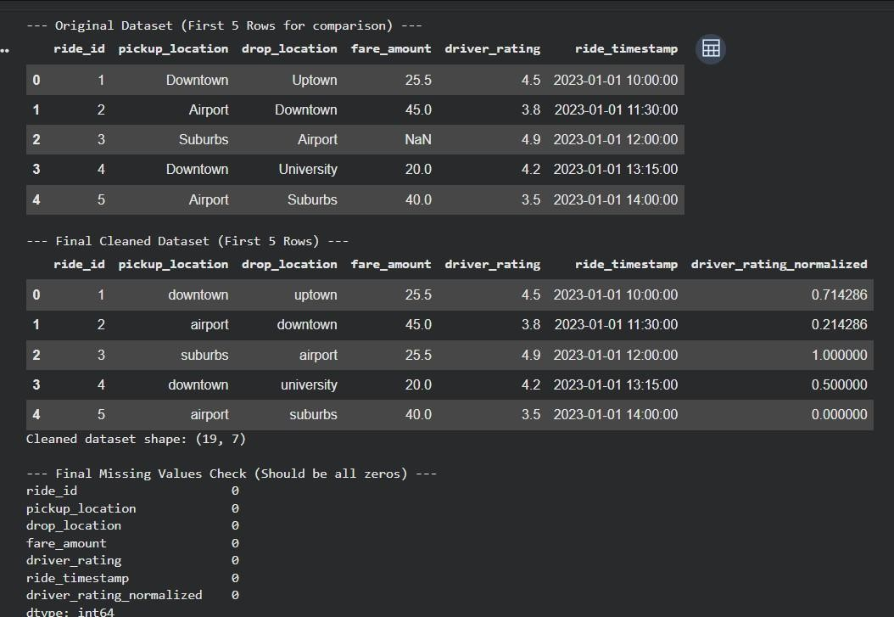
Output:

Explanation: The program begins by loading the ride-sharing dataset with pandas and displaying the original data to allow comparison after processing. It then standardizes the location columns by removing extra spaces and converting all text to lowercase, ensuring that identical locations are not treated differently due to formatting variations.
Missing values in the fare_amount column are filled using the median fare to avoid the impact of extreme values on the data. Duplicate records based on
ride_id are eliminated to keep each ride entry unique and accurate. The
driver_rating column is scaled using Min-Max normalization to bring all values into a uniform range. Finally, a summary is produced highlighting the number of corrections made, and the cleaned dataset is saved for further analysis.

